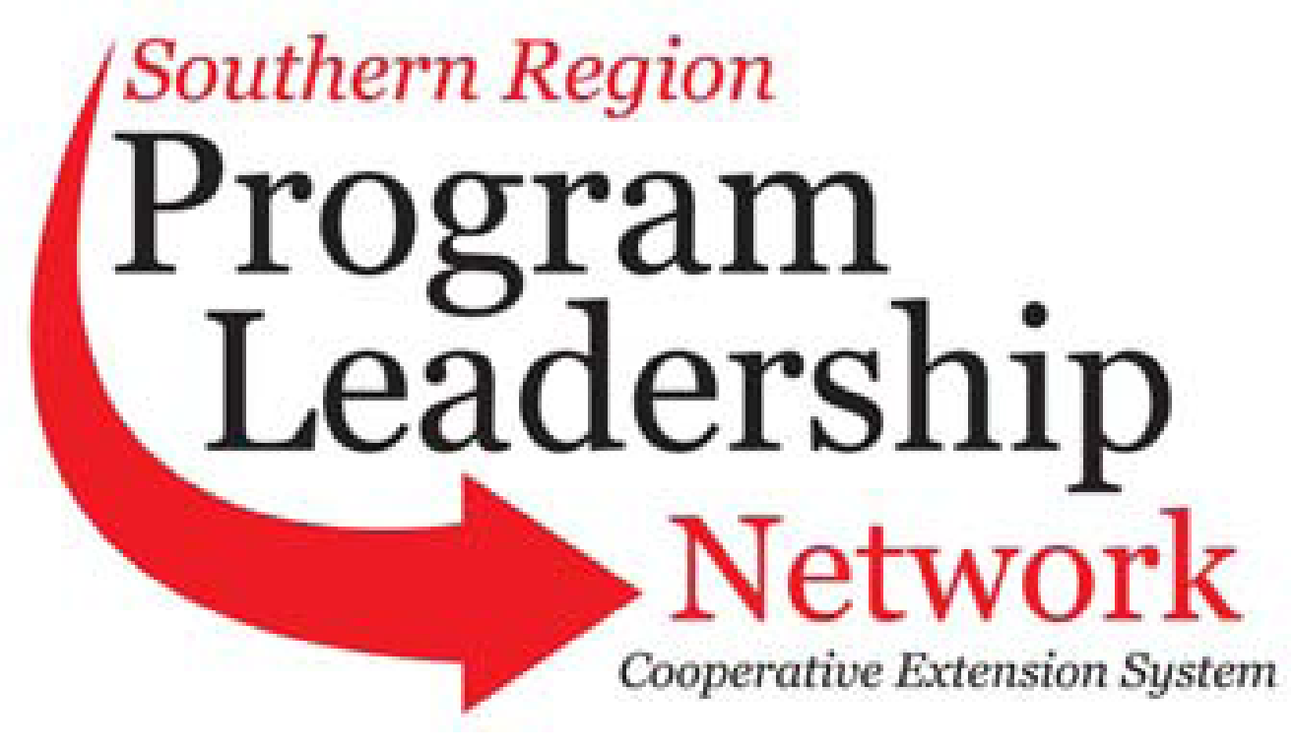
New Committee Officers and Key Contacts
September 1, 2025 – August 31, 2026
(See submission instructions at end of document)

Committee Name | Communications | Submission Contact Name: | Sue Smith
Chair | Tracy Courage, University of Arkansas, tcourage@uada.edu | Submission Contact E-mail | suesmith@uga.edu
Vice-Chair | Vickey D. Williams, Alcorn State University, vwilliams@alcorn.edu | Submission Contact Phone | 706-518-9078
Secretary | Sue Smith, University of Georgia  suesmith@uga.edu | Date of Submission | August 18, 2026
PLC Representative 1862 | Chris Elam, Texas A&M, chris.elam@ag.tamu.edu (2027) | PLC Representative 1890 | Erica Shambley, Virginia State University,  eshambley@vsu.edu (2028)
1862 Advisor | Justin Rhinehart, University of Tennessee | 1890 Advisor | Mark Latimore, Jr., Fort Valley State, latimorm@fvsu.edu

Annual Plan of Work
September 1, 2025 – August 31, 2026

Item to Accomplish | Responsibility  (Names of people assigned to item) | Key Contact  (Person who will serve as a key contact for the item) | Goal Date  (Anticipated completion date) | Completion Date  (to be filled in when completed)
Develop a module and a one-page guide for Marketing Local Programs  Internal Marketing Local Programs | Chris Elam, Vickey D. Williams; adding Sue Smith | Chris Elam | February 2026 | Will roll into 2026-27; November 2026 for the survey completion; complete 1-pager by July 2027
Create Guidelines for Responsible and Effective Use of AI in Marketing & Communications | Vickey D. Williams, Erica Shambley, Latasha Everson, Sonya Moore-Davis | Deseray McKinzy | August 2026 | Will roll into August 2027; information compiled and guidelines started
Develop a Responsible AI Toolkit for Faculty, Researchers, and Extension Professionals | Vickey D. Williams, Erica Shambley, Latasha Everson, Sonya Moore-Davis | Vickey Williams | August 2026 | Will roll into 2026-27.
Accessibility Module and Training  - Overview, guidelines, and best practices.  - Generalized best practices and standards.  - Accessibility standards change in April 2026. | Vickey D. Williams, Lori Greiner, Hayley Pierce, Stacy Herrick, Matt Browning, Lyndall Stout, Mariah Spiva, | Stacy Herrick | August 2026 | Modules already created at an institution will be shared with the group; remaining work will roll into 2026-27.
Capture and amplify success stories of member institutions for collaborative quarterly news releases. (one pager)  - Outline process  - Standards of Operations | Frankie Gould, Tobie Blanchard, Tracy Courage, Matt Browning, Lyndall Stout, & Latasha Everson, Brian Utley | Frankie Gould | November 2026 | Outline of process was complete by August 2026; standards and stories will roll into 2027.
Develop a new PLN digital brand.  - Create a new image (brand kit for Logo) | Amy Carpenter-Driscoll, Tracy Courage, Carmen Kelly, Marquinta Gonzalez | Tracy | January 2026 | In progress as of August 2026; will complete in 2026-27.

Quarterly Conference Call Schedule: (Dates/Times – Please indicate time zone)

November 6, 11 AM EST
January 15, 11 AM EST
April 9, 11 AM EST
July 9, 11 AM EST
Submission instructions:
Rename the document with your committee name initials (ANR, CRD, COM, FCS, 4H, ITS, MM, PSD, PLC) such as: ANRplanofwork.doc
Email document to HYPERLINK "mailto:r.scammahorn@msstate.edu"r.scammahorn@msstate.edu
If you have problems, contact Roseanne Scammahorn at HYPERLINK "mailto:r.scammahorn@msstate.edu"r.scammahorn@msstate.edu

